EVALUATION REPORT FOR ZIMBABWE PARENTS FOR HANDCAPPED CHILDREN ASSOCIATION (ZPHCA)
“MAKING THE VOICES OF CHILDREN WITH DISABILITIES HEAD PROJECT 2017-2020”
--------------------------------------------------------------------------------------------------------
TABLE OF CONTENTS
Abreviations
Executive Summary
- Introductions
  - Background Information on ZPHCA
  - Summary of Work-Plan
  - Rationale for the Exercise

- Broad Objectives
  - Specific Objectives
  - Evaluation Design and Methodology
  - Inputs
  - Outputs
  - Outcomes

- Methodology
3.1 Level 1 – Inputs
3.2 Level 2 - Outputs
3.3 Level 3 – Outcomes
3.4 Date Processing and Analysis

- Limitation of the Evaluation

- Analysis of Inputs
5.1 Human Resources
5.2 System of Governance
5.3 Board of Directors
5.4 ZPHCA Branches
5.6 Financial Resources
5.7 Physical Resources
5.8 Conclusion and Recommendations

Executive Summary
The purpose of this report is to give an evaluation of the various activities that ZPHCA has been undertaking during the period of 2017 – 2020. ZPHCA is a welfare organization and one of the civic organizations in Zimbabwe involved in advocacy and training activities and is registered under the Ministry of Public Service Labor and Social Welfare specifically to represent the children with disabilities.
The results of the assessment indicate that ZPHCA has struggled at some point to meet the objectives, both quantitative and qualitative. The membership has remained stagnant despite three years of the project operation, its management capacity particularly around financial management and program implementation needs great improvement, while the Board has not been very instrumental in guiding the organization to fulfill its mandate as outlined in the project document. The economic and political environment of the past three years has made it difficult for civic organizations including ZPHCA to operate effectively and this also explains why ZPHCA has under performed in some other activities.
On the other hand ZPHCA has successfully established itself as a bon fide functional organization, which has been received by its current membership, because of its potential to provide practical up to date and relevant solutions to the plight of children with disabilities. ZPHCA has developed a full complement of policies, as well as having developing programming activities that are already being implemented albeit with success. ZPHCA has some very strong and viable members who are visible at local and branch level, well versed and experienced in representing the plight of children with disabilities.
This Monitoring and Evaluation report document the findings is an analysis and recommendations of a review of the Making the Voices of Children with Disabilities Heard implemented by Zimbabwe Parents of Handicapped Children Association (ZPHCA) with financial and technical support from Headway Africa for 3 Years from April 2017 to March 2020. The Project was aimed at strengthening the voices of children with disabilities at Family, Community, Local Authority and National Level. The review sought to map and analyze ZPHCA’s experience, knowledge and capacity regarding the promotion of the rights of children with disabilities, and make pertinent recommendations. The review comes at a time when the focus is being made to work towards the attainment of disability inclusion from family, community, local, national and international level in line with the Sustainable Development Goals. Globally, there are strong calls for the rights and needs of children with disabilities to be more effectively incorporated in planning, budgeting, policy making, decision making, implementation, enforcement, and programs. Designing practical implementation programmes remain a key challenge. ZPHCA managed to raise awareness amongst thousands of community members on the rights of children with disabilities in line with the National Disability Act and the United Nations Convention on the Rights of Persons with Disabilities. ZPHCA created conducive platforms for children with disabilities to articulate, advocate and lobby for their Rights, protection, promotion and fulfillment. The review process included program reports, advocacy material, key informant interviews, survey questionnaires, focus group discussion and field visits. The major activities implemented by ZPHCA under the Headway Africa funded Project included hosting children with disabilities, leadership workshops, Advocacy and Lobby Training Workshops, Whistle Blower training workshops, Fathers Workshops, Stakeholders Engagement Workshops, Advocacy Campaigns, Disability Awareness Campaigns and Commemorations of important International Events. The major challenge in the field of disability is that of change of community attitude towards children with disabilities at community and Institutional level, which is a long-term process requiring long term interventions at most hence ZPHCA needs to further strengthen, expand and continuously improve its Disability Advocacy Programs. The major lesson learnt during the implementation of the project period was that; Disabled children are not just mere recipients of ideas and interventions imposed but they can become meaningful contributors and partners in finding solutions to issues that concerns them, their families and communities. It was concluded that ZPHCA needs to further strengthen with partners for the establishment of Children with disabilities coalition. Initiatives aimed at lobbing policy and budget to allocate more local and national resources towards children with disabilities empowerment programs is one way of alleviating rampant child poverty. The major recommendation drawn was that ZPHCA and its Stakeholders needs to include Children with Disabilities into all Organizational Decision-Making Structures including ZPHCA Board to ensure true inclusive participation of children with disabilities.
Through the support of Headway Africa and other local stakeholders and ZPHCA membership managed to implement the following specific Goals; -
SUB – GOAL 1- Increased activities by other Partner organizations on attitude and knowledge about disabilities in Zimbabwe.
SUB – GOAL 2 – Availability of resource persons on Local and Regional Level as Ambassadors and trainers for ZPHCA and other organizations, for the rights and equality in the society for disabled persons.
SUB – GOAL 3 – Strengthen the organization on the skills for an increased organizational structure

- Introductions
Background Information on ZPHCA
Zimbabwe Parents of Handicapped Children Association is a Welfare organization of parents of children with all forms of disability. The Harare branch was started through Parents meeting at out reach points administered by Harare Hospital Children’s Unit in 1988 in Glen-View. Since then more groups have now been formed to compliment and be representatives of children’s disability. Having been operational for many years, the association is one of the oldest and largest branches of Zimbabwe Parents for handicapped Children Association groups that are in Zimbabwe. It became a formally recognized Welfare organization in 1990. As a Welfare organization (W.O.7/90), was formed to provide parent to parent support, relief care to parent, stimulation for children with disabilities, income generating activities and to lobby for better social services for the children with disabilities.

- Summary of Work-Plan/Project document, vision, Mission, Values

The main guiding document in this project is the matrix strategic plan for the project, outlining the activities during the period under review. The strategic plan was as a result of an extensive involvement of the Board and other stakeholders that are in partnership with ZPHCA. The initial project document outlines the vision, Mission, Values, objectives that the organization goes by and these are what is under review as part of the assessment.
2.1 ZPHCA’s Vision
ZPHCA’s Vision is to improve the lives of children living with disabilities by promoting, protecting their rights and representing them in areas where their rights are violated as stated in United Nations Convention on Children’s rights.
2.2 ZPHCA’ Mission
ZPHCA mission is to improve the quality of life for children living with disabilities through protecting their rights as in terms of the United Nations Convention of children’s Rights and the United Nations Convention on the Rights of Persons with Disabilities. ZPHCA also seeks to promote co-operation between other civic society organizations and Government including Quaz Government Institutions in order to link up and promote the rights of children with disabilities. The organization employs a small staff of the Programmes Coordinator, the Project Officer, Finance Officer and the Administrative Secretary.

2.3 ZPHCA Objectives
ZPHCA has many of its objectives which include;
- Providing a platform to exchange information /experience and advise in the area of various disabilities to parents
- To monitor and evaluate legislation, programmes and services affecting the welfare of children with disabilities.
- To monitor and maintain cooperation with the Government, NGOs and other organizations interested in the education, training and rehabilitation of children with disabilities.
- To promote and encourage education, training, rehabilitation and general welfare of children with disabilities and assist their families to meet their special needs.
- To carry out fundraising activities to enable the association to fulfill its objectives.
- To liaise with professional bodies and act as a pressure group, with the hope of bringing about positive change in the policy, to improve the lives of our disabled children.
- To promote human rights of children living with disabilities.
- Provision of quality and appropriate health and rehabilitation services to children living with disabilities.
- Lobbying and advocating for legislative policies and services that affect children with disabilities and their welfare.
- Lobbying and advocating for women land and property rights as an integral part to care for children living with disabilities.
- To create platforms to share experiences using the Study Circle Methodology and then lessons learnt should be used to build capacity of the organization.
2.4 Values;
- Team Work
- Honesty,
- Creativity and
- Valuing an Individual.
The main policy framework for ZPHCA work programme is articulated in the project plan document. The parents who are a tool to provide a means main values and principles guiding ZPHCA include a community focus where it works with its membership to constantly ensure that the voices of Children with disabilities are heard at both Local and National Level through this capacity building project. The project role was to build capacity of its members to better serve their centers. ZPHCA endeavors to provide a platform on which a multiplicity of players with diverse activities and interests can participate in order to promote and strengthen children with disabilities through their to the children for understanding what is going on in communities and thus providing their own solutions to what ever problems they face. ZPHCA members cannot only limit themselves to service delivery and production activities. They have to confront the causes of social injustice and poverty to their own children with disability. ZPHCA in this project attempted to promote a democratic culture and participation in which members have a say in the policies and activities of the project.
3.1 Rationale of the Intervention
ZPHCA Implemented the Making Children with Disabilities Voices Heard through imparting leadership, advocacy and lobby and engagement skills to children with severe and multiple disabilities so that they can individually and collectively challenge their continued Rights Violations including stigmatisation, discrimination, economic deprivation, segregation from community developmental programs and lack of social safety nets provision amongst others. In implementing the Project ZPHCA partnered and networked with various stakeholders including the President’s Office, Government, Department of Social Welfare, Health Institutions, District Administrators, The Study Circle Alliance of Zimbabwe, City of Harare, Traditional Leaders, Disabled Persons Organizations, Community leadership, Membership and Media amongst other Stakeholders. The project was intended to contribute to overcoming the exclusion and marginalization of children with disabilities and improve their living standards. Furthermore, ZPHCA intended to initiate various community and national platforms for children with disabilities to interface with various stakeholders advocating and lobbying for their Rights, fulfilment, attitudes change amongst stakeholders and communities. Demanding participation and inclusion in all family to National decision making policies, budget formulation and other platforms for disabled children was also a major highlight.
3.2 Human Rights and International Instruments
Specific Objectives of the evaluation
ZPHCA envisions an inclusive world in which children with disabilities attains the right to food, health, survival, protection, development and participation amongst other Rights. Its work is guided by the UN Convention on the Rights of the Child (UNCRC) and the United Nations Convention on the Rights of Disabled Persons (UNCRPD). UNCRPD to be more specific gives ZPHCA, Governments and other stakeholders a much stronger impetus to promote, protect and ensure the full and equal enjoyment of all human rights and fundamental freedoms by all persons with disabilities. Within the framework of international instruments such as the UNCRPD and UNCRC, Organizations like ZPHCA have a clear mandate to ensure that children with disabilities are included in programmes and advocacy activities, as active participants and change agents, rather than as passive recipients of charitable help. This is despite the fact that poverty and disability are inherently linked and disabled children families are more likely to experience economic and social disadvantage than those without disabilities”
Such an evaluation of the organization and the project is the subject of this report. This is one of the systematic strategic evaluation process which is performance based given the prevailing socio-economic and the political environment in Zimbabwe. The substantial financial resources poured by Headway Africa into ZPHCA and the constant changing and fluid socio economic and political environment justify the need to assess and evaluate the performance of the project. It has never been easy to collect project money from the banks. At some point there was a second thought to open a bank account in Zambia where its hassle free. From a fair scenario concerning capacity building of leadership and its membership, three years is too short a time to measure the impact that ZHPCA has had to its organization. Monitoring and evaluation of progress or lack of progress, is critical in ensuring that the best possible services are being delivered and that there is sustainability. In short, after the three years, the nation should ask if ZHCPA is adding value to the work of children living with disability or not.

  - Broad Objectives
The purpose of the objectives is to generate information on the extend to which ZPHCA as representative and network organization is achieving
its objectives as set out in the project document. In summary, the assessment is supposed to provide information on the major achievements of ZPHCA to date, both quantitatively and qualitatively.
- Assess how plans and goals in general were followed during the three year project period.
- Assess gender equality between women and man. Has the project promoted the mainstreaming of gender in project activities?
- To review the performance of the organization with respect to achieving its objectives as an organization.
- Assess eventually strengths, weaknesses and opportunities for ZPHCA in the now finalized projects and elaborate recommendations on how to address them.
3.4. Evaluation Design and Methodology
A participatory approach to this Monitoring & Evaluation exercise was adopted including working closely with disabled children, mothers of disabled children, fathers of disabled children, ZPHCA Board Members, ZPHCA staff members, community members, Traditional Leaders and Stakeholders. A Participatory Approach was crucial in influencing positive feedback and cooperation by all the stakeholders reached during the data gathering stages. The Monitoring and Evaluation was undertaken at the end of the Project between March 2020 to April 2020. The Participatory Methodology adopted 5 Strategic Stages in general and these include:
- Initial consultations and review of relevant documents including activity reports, policies, case studies of change and advocacy material.
- Information gathering including field visits, questionnaires and interviews.
- Hosting Focus Group Discussions
- Monitoring and Evaluation Workshop for 30 Children with Disabilities and the mothers.
The five stages of evaluation will be defined and summarized in these three levels;
INPUT OUTPUT OUTCOMES/RESULTS
3.5 Input
This represents resources, funding budget from Headway Africa and expertise that were at the disposal of ZPHCA/ Headway Africa project and the activities that were involved over a period of three years. The input represents the staff and Board members including members of the ZPHCA who worked hard to network, physically and other facilities and funds committed to the network. Included here is the adequate administrative systems as well as the Constitutional Governance Structures that oiled the project to achieve project objectives. The assessment will determine the level and quality of the inputs and efficiency with which they were applied in achieving the objectives of the organization. Expertise includes SCAZ as the facilitating organization in all issues concerning advice, training and capacity building of both members and the organization. These inputs are normally associated with the Project Coordinator and Staff members as implementers though the role of how the funding partner efficiently and adequately contributed financial support was also examined.
Information for this evaluation was gathered through reviewing the following documents;
- ZHPCA/ HEADWAY AFRICA project document
- Goal and Risk Matrix for project grant application
- Project –Headway Annual Work Plan
- ZHPCA Project Annual narrative reports
- Headway Project Budget
- ZHPCA Board and Leadership interview Forms
- ZHPCA Stakeholder & Partners Interview Forms.
- Human Rights and International Instruments

3.6 Output
This refers to activities carried out by ZPHCA. These were mainly represented by activities of the Staff and Board members and the ordinary members in the organization. These included information disseminated to members, training activities carried out for members, technical advise given and acted upon or not, workshops/ conferences held to advance the objectives of the organization and deepen the understanding of the project approach, lobbying and advocacy done to influence Government and other stakeholders for the promotion of children with disability. This assessment also determined the relevance of activities to the members or parents of children with disabilities. The evaluation also included determining the quality, effectiveness and efficiency of the project interventions in meeting expectations results or failure to do so and the reasons.
3.7 Outcomes
This refers to the effect ZPHCA has had on its members. This also includes an evaluation on how strong the concept of networking is among members. Outcome of ZPHCA included member’s perception of the services received from the Stakeholders. The results in form of benefits being derived from the three Headway Africa Project Goals through various planned activities are a clear testimony of the outcomes from the project. This is clarified and confirmed by the concluding recommendations in this evaluation report.
4.1 Methodology
4.2 Input
Level One
The methodology for the evaluation of inputs included unstructured interviews with the Coordinator and other members of staff directing and working on the project.
These were held with a number of technical and management, ZPHCA staff, Board Members, Focal Persons, Children with Disabilities, Fathers and 10 Key Stakeholder were interviewed. Some interviews were done through face to face, skype calls and phone calls.
Level Two
Semi-structured interviews: These interviews used sets of guide questions based on the overall review questions. Interviews were mostly held with ZPHCA staff, government personnel and representatives from other organizations working on disability and/or children’s rights in the country..
Focus Group Discussions; These were often combined with participatory activities such as drawing, making diagrams, photo elicitation and photography which can help to engage participants and promote reflective thinking more effectively than a basic group discussion. Focus groups were mostly held with children, with and without disabilities (5 focus groups in total); parents (5 focus groups) and hosting 1 Focus Group for Focal Persons (Focus Group Questionnaires Guide is attached).
4.3 Survey
A short survey was developed and questionnaires directed to stakeholders, Staff Members, Children with Disabilities and Families of the disabled children were designed and completed. 23 children with disabilities, 23 mothers of children with disabilities, 5 Fathers, 10 Board Members, 3 Staff members and 13 Stakeholders participated through completing the Survey Questionnaires (Survey Questionnaires are attached). Data Analysis and Report Writing
4.4 Date Processing and Analysis
The data was organized and documented within the framework of research questions attached. Data collected through interviews of the documents, key informants interviews and self administered questionnaires were consolidated and synthesized to allow comparison and cross checking of project inputs, outputs and outcomes as perceived by the respondents at various levels.
5.1 Limitations to the evaluation
The time given for this evaluation was rather limited as it was difficult to access the members, stakeholders, children with disabilities, traditional leaders and even the staff under the World Pandemic Covid 19 Virus circumstances. It was also not possible to visit the respondents to the same constraints mentioned above. The respondents reached were limited and those interviewed were done using a systematic sampling method to represent those unreachable.
5.2 Findings from the Analysis of inputs
The ultimate aim was to assess management capacity of ZPHCA to deliver with all the resources made available through the project. The following were the precise results of the interviews;
GOAL 1; Increased activities by other Partner organizations on attitude and knowledge about disabilities in Zimbabwe. SEK 165.00
Activity 1.1
Meetings for and /or Instructions aimed to improve access to information & material related to the rights of Disabled Children written in vernacular language.
Participating Groups | Female | Male | Attendance | Percentage  Representation | Comments
Board members | 8 | 2 | Full Capacity | 100% | Gender equality in ZPHCA is biased towards women
Centre Leadership | 64 | - | Full Capacity | 100% | - Chairpersons  - Secretaries  - Treasurers
Local Authority | - | 4 | Full Capacity | 80%
Children with disabilities | 17 | 8 | Full Capacity | 60%
ZPHCA Staff | 3 | 4 | Full Capacity | 100%
Local Leadership | 1 | 2 |  | 50% | -The Chief  -Member of Parliament  -The Mayor

Activity 1.1 Summary of findings
Funding of this activity was not enough to meet the cost of the activity, ZPHCA managed to develop material in form of a hand book or manual to be used for training by the Local and Regional Trainers. The organization managed to develop the material in English with the aim to translate it into Shona and Ndebele as the main common vernacular languages in Zimbabwe. The budget could not meet even half of the cost of translation. During the initial stages of budget formulation, translation was never included hence unavailability of resources for translation. Three workshops were held with the same participants who committed themselves to be available to produce a hand book to be used as a training Manual. This was held with other stakeholders to understand more about issues of disability including the UN principles on disability.
ZPHCA Developed the Handbook through the involvement of the above participants to the forum. ZPHCA availed other materials previously produced for purposes of producing a handbook that is consistent. Also to the advantage of ZPHCA was the experience of the participants in material development which included the production of a pamphlet that made the work easier? The Study Circle Alliance of Zimbabwe facilitated the process of Material development using the Study Circle Methodology. The material included,
- Human Rights and Children’s rights
- UN Fundamental Principles on disability
- Socio - Economic and Political rights for the Disabled Children
- Health, HIV and Rehabilitation
- Structural Communication
- Income Generating Projects
- Advocacy and Disability issues
- Leadership Qualities
- Gender & Disability rights
- Child Stimulation.
The activity concerning material development remained incomplete as the funding could not meet full cost of translating the Handbook to the vernacular languages as was the objective of the activity plan. The beneficiaries failed to benefit from this activity particularly those who cannot understand English. Another aim was to educate communities linked to ZPHCA using the handbook which can easily be understood as a manual to the training. The majority of children and parents are semi literate hence the project activity to translate the training handbook to vernacular languages. Translation was abandoned due to lack of a specific budget which during planning was also not made smart and clear. Imagine a half baked cake due to electricity blackout. What it means is that all the effort and financial resources used to bake the half cake were a waste of resources, especially when the project has come to an end and with an incomplete activity.
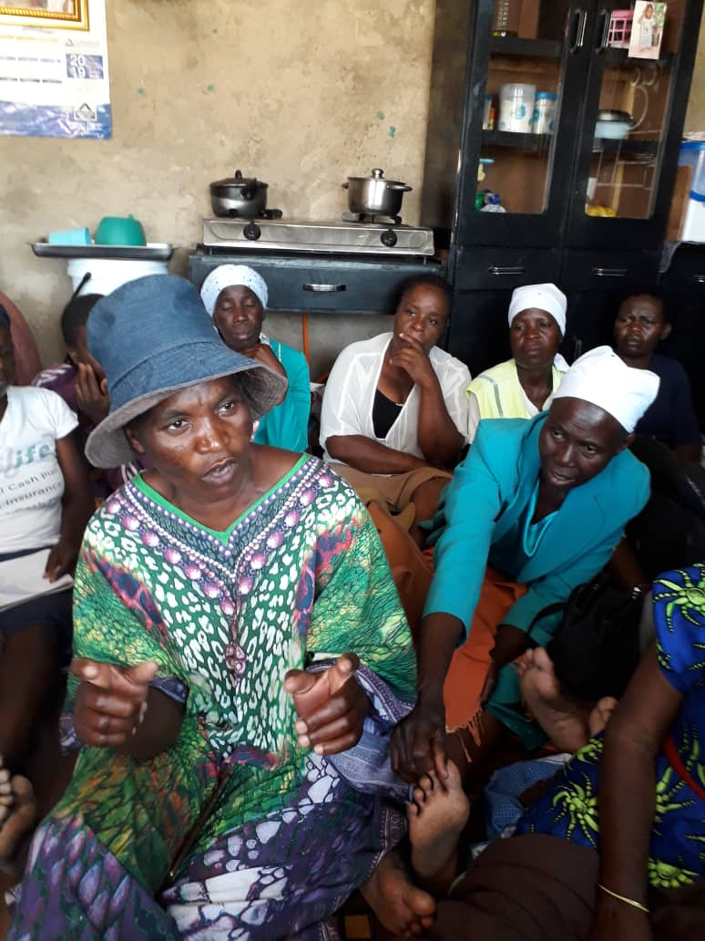
A Meeting aimed to improve access to information & material related to the rights of Disabled Children in vernacular language
Activity 1.2
Three Formal Meetings with Local Authorities for internal and External Information about Children’s Social Rights.
Participating Groups | Attendance | F | M | Designation
Board members | Full Board | 45 | 15 | Board
Centre Leadership | 64 Centers | 154 | 15 | - Chairpersons  - Secretaries  - Treasurers
Local Authority | 4 reps | 12 | 6 | - The Harare City Mayor  - Housing Director  - Deputy Director Housing  - Harare City Social Worker  - Harare City Chamber Secretary
Children with disabilities | ZPHCA Children | 17 | 21
ZPHCA Staff | Full Capacity | 9 | 10 | - ZPHCA Coordinator  - ZPHCA Finance Officer  - ZPHCA Projects Officer  - ZPHCA Clerical Staff X 2
Activity 1.2 Summary of findings
Three formal meetings constituting high level of engagement with the Local Authorities, achieved many benefits to ZPHCA resulting in some members being allocated housing stands to Accommodate their children with disability. The three meeting activities were;
- To engage Local authorities on Children with disability rights fulfillment
- Meeting aimed at improving access to information
- Formal meetings with Local Authority for internal & external Information sharing.
- Meetings on the strategy for beneficiation to ZPHCA

There was also a Memorandum of Understanding to give preference to children with disability in any social service being offered to the community such as;
- Housing Stands Allocation
- Any Charity donation from the Mayor’s Cheer fund
- Use of the Harare City Council facilities
- Representing Children with disability in policy formulation
- Advancing proposals from ZPHCA in the Chamber e.g. Compelling rumps in Harare City Council Building Plans.
- Exempting ZPHCA from Parking fees in the City of Harare.

During interviews with the Board Members, at times they feel short changed by the Local Authorities as they don’t adhere to MOU at all times. They expressed gratitude to Headway Africa for creating the network to engage the Local Authorities. Off course not all can benefit at once but it depends on what is possible at a time. The job and election turn over at the Local Authority sometimes has disadvantaged ZPHCA since Elections bring in new people and also changing positions of senior personnel to new people. This requires another circle of introducing the subject matter to new personnel through workshops of which the project budget cannot and in any case cannot accord that opportunity. Though with many challenges, this activity was a success. It was possible to engage the Local Authority and ZPHCA is already benefiting in certain things as elaborated in the list above. Majority of members in their different Centers are aware of how to respond to the Harare City Council requests.
Activity 1.3
Four Workshops with Stakeholders (New Organizations) to Establish cooperation on Children’s Social Rights.
Participating Groups | Attendance | Designation
Board members | 25 | Full Board
Centre Leadership | 64 Centers | - Chairpersons  - Secretaries  - Treasurers
ZPHCA Staff | 6 | - ZPHCA Coordinator  - ZPHCA Finance Officer  - ZPHCA Projects Officer  - ZPHCA Clerical Staff X 2
Teachers | 15 | - Headmasters  - Teaching Representatives
Police Officers | 15 | - Child-line Police Officers  - HIV/AIDS Desk  - Gender Violence Desk
Churches | 20 | - Pastors/Prophets/Apostles  - Church Elders  - Bishops  - Church Evangelists  - Church Guilds Leaders
Activity 1.3 Summary of findings
An interview of both the teachers, police, Board Members and the ZPHCA Coordinator reveals that the interaction was very educative and very informative. Many challenges were experienced through failure by the police to handle issues fairly concerning disabled children. Equally, the same with Schools, they denied children with disability the right to education by deliberately refusing to offer them placements at their schools. The workshops brought new relief to ZPHCA and other organizations of disabled persons. The programe could have been a continuous process had it not been due to in adequate financial resources that could not cover visits to schools and police stations for purposes of familiarization. It would have been good and complete if the stakeholders could have visited the Schools and the Police Stations. As for the Churches, it was agreed that they can assist by providing social and economic interaction with the disabled children since some children come from very depressed families and even in situations that are more than one disabled children in a family. By consensus in all the workshops, it was agreed that Churches should play a crucial role in providing counseling to the parents and the children. Churches should provide relief spiritually. The police should treat disabled children cases with merit rather than to under play issues brought by the parents. The Schools were advised to develop a policy that provides at least a minimum percentage as a reserve for disabled children at schools. The project provided enough budget to create such interaction with the Social Partners or Stakeholders that are critical to achieve the objectives of the funding.
Activity 1.4
Marketing and Awareness Campaign for Children with disability
Participating Groups | Campaign Method | Output | Material Used
Board members | Meetings &  Workshops | Full Board | - Policy Minutes  - ZPHCA Handbook
Centre Leadership | -Meetings,  -Workshops &  -Expos Displays | - Chairpersons  - Secretaries  - Treasurers | Banners, Placards  Pamphlets, Expos
ZPHCA Staff | -Meetings  -Workshops  -Expos displays  -Media-Electronic &  -Print media. | - ZPHCA Coordinator  - ZPHCA Finance Officer  - ZPHCA Projects Officer  - ZPHCA Clerical Staff X 2 | Banners, Meetings with Stakeholders, Participation at Expos, Music extravaganza, Writing to stakeholders like; Police, Schools, Gvt, Local Authorities etc.
Teachers | -Drama displays  -Advocacy material  -Teaching method | - Headmasters  - Teaching Representatives | - Drama in schools  - Charts  - Involvement of Disabled Children in School projects.
Police Officers | - Media; Electronic,  - Print Media  - National Match  - Meetings  - Workshops | - Child-line Police Officers  - HIV/AIDS Desk  - Domestic Violence Desk | - Posters in all Police camps  - Protection of disabled children in rape or related cases. Etc.
Churches | - Sermons  -Teaching method  -Evangelism  -Out-reach  - Home visits | - Pastors/Prophets/Apostles  - Church Elders  - Bishops  - Church Evangelists  - Church Guilds Leaders | - Out-reach programmes to visit homes of children with disability.  - Counseling programmes for thedisabled/parents/Guardian  - - Provide Social & donations.

Activity 1.4 Summary of findings
The project provided an eye opener to social partners who previously looked down to disabled children. In many occasions there were never considerations to issues raised by the disabled children. The parents could waste a lot of resources by looking for school placements to long distance private schools. The children were denied education by the School Authorities due to disability. Though the budget was not adequate for interaction and training workshops for the stakeholders but much attention was given to this activity as a way to provide awareness to Social Partners and Stakeholders in providing social welfare to the children. In future, ZPHCA should go beyond the traditional partners or stakeholders and establish new partners as a way to broaden the networking. The workshops involved many stakeholders including the Churches, Police Officers, Local Leaders, Chiefs, NGOs, and other stakeholders. The workshops were meant to market and bat the same time bring awareness about the needs for children with disability so that when ever they knock at their doors, readily available assistance will be rendered.
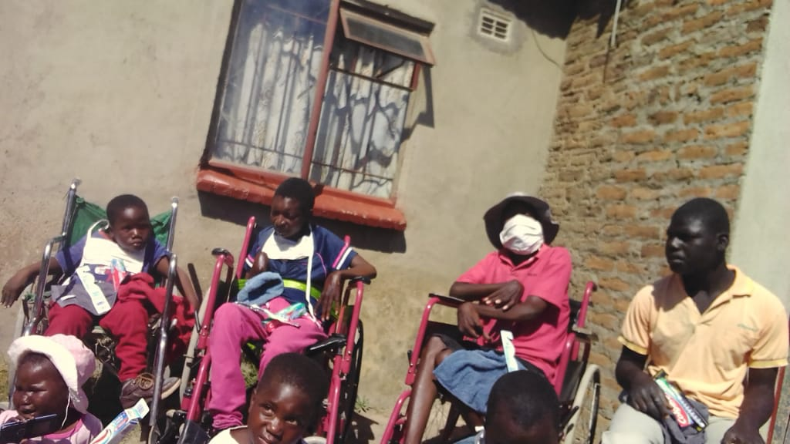
Awareness Campaign for Children with disability

SUB-GOAL 2; TRAINING OF RESOURCE PERSONS SEK 90.00
Activity 2.1 Producing ZPHCA Strategic Plan for resource mobilization
Activity 2.1
Producing ZPHCA Strategic Plan for Resource mobilization
Participating Groups | No. of Participants | Output | Material Used
ZPHCA Members | 25 | Policy Decisions | - Minutes  - Constitution
Local Leadership | 4 | - Programmes for implementation | -Reports from the Centers
ZPHCA Staff | 7 | - Budget Proposals  - Type of Activities  - Networking Organizations  - Fundraising areas  - Target Groups | -Budgets and Reports  -Policies  -Previous strategic material  -Government Policy  -UN Declarations on Disability  -Experience
ZPHCA Fathers | 18 | - Networking  - Policy decision  - Advocacy | -Experience of disability child  -Gender representation
Local Authority | 5 | - Memorandum of Understanding  - Activities in Council Premises | - Policy regarding disabilities
SCAZ | 3 | - Facilitation  - Handouts  - Report | - Research Material  - Experience  - Activity Methods
Children with Disabilities  (Young Adults) | 20 | - Recommendations  - Creation of groups  - Self help activities | - -Self Representation

Activity 2.1 Summary of findings
The above stated groups met to develop a strategic plan for ZPHCA which was segmented in one year each for three years as was the project period. Activities were planned according to the budget allocation for the entire project. However, events and eventualities particularly the Zimbabwean socio-economic environment shifted many plans including reducing the budget to a deficit due inflation and other limiting factors surrounding the inadequacy of the funding. A change in currency and limitation to secure cash from the banks became a stabling block to smoothly accomplish the goals to achieve the positive outcome of the project. The cost of transport, cost of workshop materials and other requirements skyrocketed and affected the financial ability of the project. Transfer allocation as agreed before in the Memorandum of Understanding could no longer meet any meaningful activity, resulting in some activities being compromised. Never the less under such difficulties, the strategic plan was achieved with all the players present.
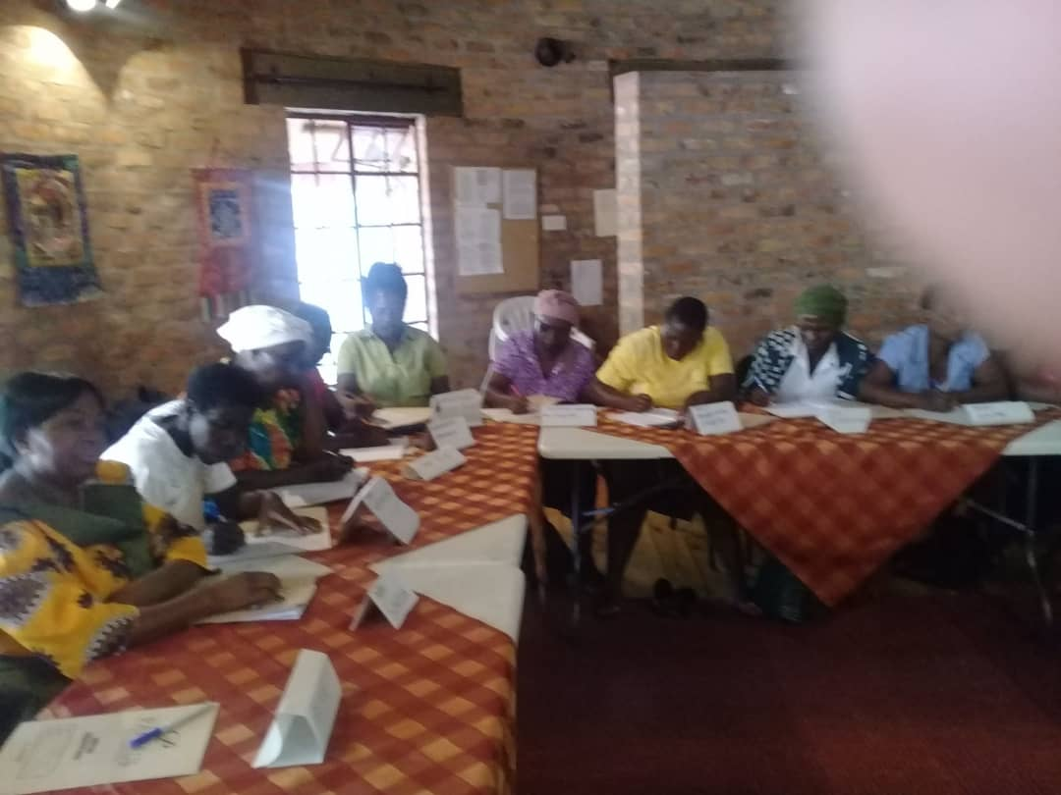
ZPHCA Board and Leadership in a Strategic Planning Workshop
Activity 2.2
Four Training Workshops on Whistle Blowers, Fathers, Sustainable development.
Participating Groups | Attendance | F | M | Designation
Board members | Full Board | 45 | 15 | Board
Centre Leadership | 138 | 154 | 15 | - Chairpersons  - Secretaries
Fathers | 20 |  | 20 | - Harare centers
Whistle Blowers | 25 | 20 | 5 | - Harare Centers
Members | 30 | 23 | 7 | - Harare Centers
Young Adults | 25 | 17 | 8 | - - International & Local Youths

Activity 2.2 Summary of findings
Four workshops to train Whistle Blowers, Fathers, Young Adults and general membership on various subjects were held. The training experts came from the Study Circle Alliance of Zimbabwe as the training Consultancy. The workshops included the following;
- Basic training in report writing and Child Rights for Whistle Blowers
- Basic Agricultural Skills for General Membership
- Basic Human and Children’s Rights for Fathers of Children with disability.
- Basic Training in Sustainable Development for Young Adults
Whistle Blowers were trained to be ZPHCA informers for any child abuse in communities and even in Public Offices. These were given basic skills in report writing and Child Rights so that they are able to identify the difference between wrong and right. Also instilled in them are report writing skills. All the courses were trained not in a single day but through a process which needed enough resources to cover for the training. This was the same with the general membership course and Basic training in Sustainable Development. The youths were a mixture of both girls and boys from across the centers. The invitation to these workshops were sensitive of gender representation though could not achieve 50/50 representation. The gap experienced was the lack of consistence in their attendance. For the youths it may have been due to transport challenges which the budget carter for that. This brings to fore that during planning process the budgeting process was not thorough and inclusive.
Activity 3.1
One Workshop on Planning for the future of the Project.
Participating Groups | Attendance | F | M | Designation
Board members | Full Board | 45 | 15 | Board
Center Leadership | 138 | 154 | 15 | - Chairpersons  - Secretaries
SCAZ | 5 | 1 | 4 | -Chairperson  -Director  -Admin Secretary  2 Executive members

Activity 3.1 Summary of findings
The workshop was attended by the Board members and members of ZPHCA. The objective of the workshop was to plan for the future without a project. How the children would benefit after the project. The issue of sustainable development included Market Gardening, Conventional Agriculture, Home Nursing and Early Childhood development skills training. ZPHCA also planned development of skills development to children with disability. The facilitation was done SCAZ as the contracted Consultant.
Activity 3.2
One Workshop on the Inventory of Needs, resource persons, Skills and Tools for continuation.
Participating Groups | Attendance | F | M | Designation
Board members | Full Board | 45 | 15 | Board
ZPHCA Staff | 138 | 154 | 15 | - Chairpersons  - Secretaries
SCAZ | 5 | 1 | 4 | -Chairperson  -Director  -Admin Secretary  2 Executive members

Activity 3.2 Summary of findings
Skills development was imparted to the Board members, staff and the Centre on the rights of children with disability. An inventory on the needs of the children with disability was tabled and discussed. The majority of challenges were the unavailability of Social Services to the Children resulting in creating poverty among the disabled children through out their generation. Skills in policy development was imparted through sharing of skills. Other skills such as the Administration of the organization, Management skills, Interpretation of the constiotution, formulation of project proposals and ICT training for staff members was also provided by Headway Africa in the project. The principal reason for such skills to the staff, the Board and centre leadership was to administer the organization professionally. The other reason was meant to reduce conflict in the organization through failure to follow the provisions of the constitution. The Staff should be able to develop organizational policies such as finance policy, the Administration policy etc.
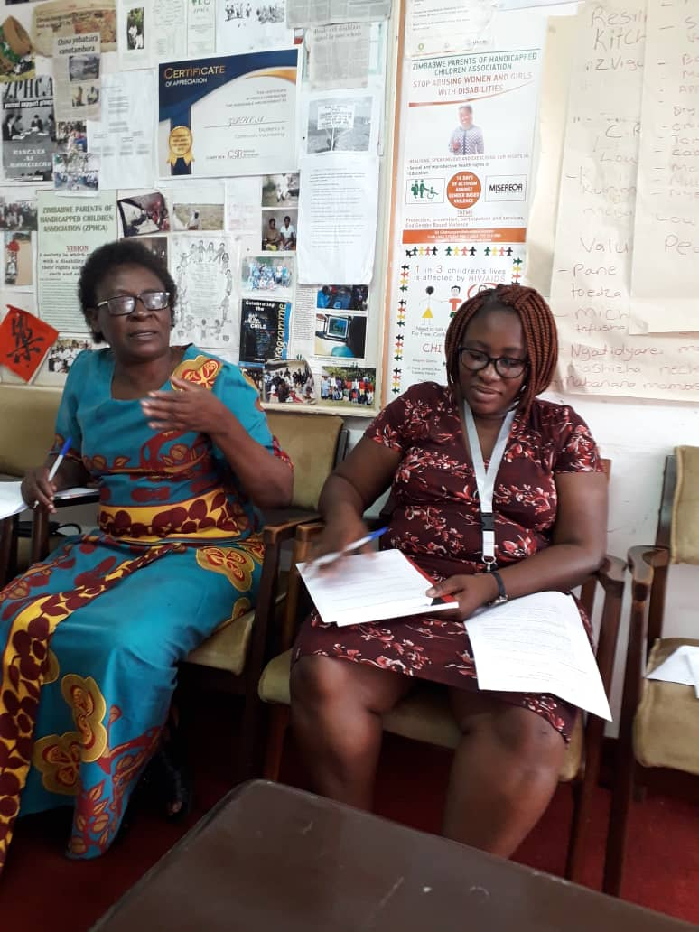
Participants attending a ZPHCA Inventory of Needs, resource persons, Skills and Tools Workshop.
6.0 Advocacy
ZPHCA through the 3 Year Headway Africa funded Project was addressing disability from a child rights governance perspective, collecting information and using this with partners to lobby for government and local authority resources to allocate and support children with disabilities. ZPHCA could further take a leading role in developing a national advocacy campaign that promotes the localization and popularization of UNCRPD and encourages its use as a framework for planning and monitoring programme interventions or external advocacy around the rights for children with disabilities.
The following were the Key Demands made by children with disabilities to the City of Harare, Government of Zimbabwe, ZPHCA and other community stakeholders during the Implementation period:
- Free access to Sexual and Reproductive Kits to disabled girls.
- Equal treatment between disabled children and the able-bodied children at family, community and at Institutional Level.
- Equal participation of children with disabilities at school, sports, art, religious and culture events.
- Equal Economic Opportunities for children with disabilities and their families including Government agricultural input support, Business Loans, Business Stands, Vending Stalls and business training.
- Equal access to housing stands for children with disabilities and their families.
- Decent clothing for all children with disabilities.
- Fairness in families, children with disabilities should always be consulted on key family decisions and community decisions.
- Access to quality and quantity food items for their dietary and nutritional requirements.
- Representation of children with disabilities at every level of decision making that is at community, local authority and national level.
- Disability inclusion in all Local Authority, Public Space and Private Institutions Buildings Policy.
- Access to Sign Languages at Vocational, Technical and Tertial Institutions.
- Free access to information and technology for children with disabilities.
- Free access to water, sanitation and hygiene promotion services.
- Right to quality and quantity health services.
- Free access to Public Transport.
- Access to Local Authority and Government Social Grants.
- Considered for Leadership Positions and being voted into political offices.
- Access to free and affordable Justices.
- Equal access to inheritance, own properties, businesses and resources.
7.0 Disability Policy
ZPHCA has a Youth with Disability Policy developed in 2017 with the active participation of disabled children however children with disabilities are not yet very familiar with National Disability Policy. Nevertheless, ZPHCA’s commitment to reach the most marginalized and deprived is well articulated and being driven by passion.
8.0 Conflicting Disability Issues
This review does not have the scope to offer detailed situation analysis for ZPHCA’s Programmes. However, using the reviewed literature and field visits, the following emerge as key disability issues or challenges facing ZPHCA Programmes:
- Zimbabwe has disability friendly policies and has ratified the UNCRDP however lack of implementation and monitoring of such national legislation around disability rights has resulted in the continue violation of Children with Disabilities Rights.
- Disability inclusion is highly talked about in Zimbabwe, however a closer look from the Stakeholders intervention shows that disability inclusion is yet to be implemented by Key Partners such as; Government, Local Authorities and the Civil Society.
- Lack of data relating to children with disabilities is current the major challenge amongst Key Disability Stakeholders.
- Stakeholders reported that diverse forms of discrimination against children with disabilities are still prevalent and are ranging from negative community attitudes to more institutionalized discrimination (e.g. being denied access to government expanded social safety nets).
- Lack of awareness on disability among traditional leaders and community members as to what they can do to support the growth and development of children with disabilities.
- There is gross inaccessible and unwelcoming education policy to disabled children, with poor teaching/learning practices and poor teacher education being key factors, along with lack of disability friendly educational infrastructure and general inflexibility in the education system (curricula, learning time and exams).
- Poverty remains the most grayling challenge for families of children with disabilities as they are often among the poorest, divorced and hardest to reach in society.
- Children with Disabilities and their families continue to face limited social welfare/safety nets as Government continues to priorities other economic sectors than social grants to children with disabilities.
- Lack of awareness of the situation of children with disabilities within child protection domains such as sexual exploitation, abuse and child labour as children with disabilities are the most hidden in society.
- Limited focus on children with disabilities in the contexts of emergency or crisis such as the Climate Change, COVID-19 Pandemic and other Disasters, including risk and preparedness planning that includes children with disabilities.
- Generally, limited children with disabilities participation in decision-making with individual Organization Structures and Government Institutions (e.g. due to perceptions about their inabilities to attend, think or communicate).
9.0 Mainstreaming Disability within Gender
The review of ZPHCA documents including reports show that the Organization is fully adhering to gender equality with disabled girls being equal participants in all programs and advocacy activities. ZPHCA Board and management revealed that the Organization has instituted girls’ friendly programs such as Sexual and Reproductive Health Training, Awareness Campaigns and mainstreaming, Sexual and Reproductive Health in all ZPHCA Advocacy Projects.
10.0 Institutional Capacity
At the moment competency around disability appears to be dependent on institutionalized systems than individuals which is sustainable for the organization. ZPHCA staff members and the Board, for instance, mentioned that they have had a stronger disability focus in the past and have developed vast knowledge and experience through in-house and external training. It was also revealed that ZPHCA has not been affected by high staff turnover hence the availability of skilled manpower who in turn improves the quality of services delivery to children with disabilities.
11.0 Thematic sectors
ZPHCA has a long history of engagement in initiatives to promote the rights and support the needs of children with disabilities. The organization has done this through activities that specifically target children with disabilities. Various initiatives exist today, some of them quite high profile and successful. The review found that the majority of programmes and advocacy work around disability takes place within the Civil Society sector particularly amongst Disabled Persons Organizations. Within that sector children with disabilities are considered mostly within medical and welfare progammes. It was revealed that Civil and Government Organizations were yet to embrace Disability inclusion in practical terms. It was revealed that Children with disabilities are considered in the work of other sectoral programmes, although this appears not to be done routinely or comprehensively. There is also limited inter-sectoral work to support children with disabilities, although the lack of inter-sectoral work is not just an issue in relation to disability.
12.0 Recording Experience
A key challenge when analyzing ZPHCA’s current position with regard to children with disabilities is the lack of documented stories of change evidence, in media, not just written reports. ZPHCA’s planning, reporting and monitoring and evaluation requirements needs to include mandatory stories of change and quantitative evidence gathering. ZPHCA successfully managed to articulate information on how children with disabilities will be or have been included through the Study Circle Method and this needs to be continued and further strengthened for future development.
13.0 General Attitudes and Understanding
The overwhelming message from stakeholders and other review respondents was that ZPHCA supports the principle of upholding the rights of children with disabilities. Most review respondents were able to provide information or show some understanding about the situation facing children with disabilities in their respective communities both rural and urban communities. Respondents from Harare Urban, Seke Urban and Rural and Domboshawa Rural, for instance, explained that they were aware that children with disabilities are “sometimes locked or tied up” and generally neglected or denied specific care, social safety nets, assistive devices, sanitary wear, economic opportunities, basic social services and health support at home, community and national level.
14.0 Accountability
ZPHCA has done its level best in being accountable to children with disabilities, their families, communities, ZPHCA Board and stakeholders through hosting on going Stakeholders Planning, Consultative, Engagement and Feedback Meetings.
15.0 Challenges
- A common challenge related to learning from experience within the field of disability/inclusion is how to move beyond documenting the individual child case study and move towards reflecting on wider lessons for Programmes.
- During interviews, some respondents reflected on the issue of community resource center shortages leading to failed inclusion of children with disabilities in development, dialoguing and participation which needs greater focus in future Programmes.
- During interviews it was noted that change of community attitude towards children with disabilities at community and institutional level is a long-term process requiring long term interventions at most, hence ZPHCA needs to further strengthen, expand and continuously improve its Disability Advocacy Programs into the long-term future.
16.0 Lessons learned.
- Sustainability of Children with Disabilities for growth and development requires joint efforts between mothers, fathers, siblings and communities.
- Disabled children are not just mere recipients of ideas and interventions imposed but they can become meaningful contributors and partners in finding solutions to issues that concern them, their families and their communities.
- Education, entrepreneurship and practical skills acquisition by disabled children and their parents remain the gateway out of vicious cycles of poverty and exploitation.
- Success is not only in securing Funding, it is also about building partnerships, engagement, strengthening organizations, learning and sharing information, skills and experience at family level.
17.0. Conclusions and Recommendations.
- The Review concluded that ZPHCA needs to Lobby for representation of children with disability in School Development Associations to ensure that disability issues are taken aboard at every level of school development.
- It was concluded that the Ministry of Education needs to be engaged in an endeavour to make sure Schools Timetables, Curriculum and teaching aids are made more flexible to enable disabled children to attend and complete Schooling.
- It was concluded that ZPHCA needs to continue, strengthen and expand Child Disability Awareness Campaigns considering the disability information gaps amongst stakeholders and disabilities myths still prevalent in communities.
- It was concluded that considering the child disability services gaps from the government, local authorities and stakeholders, ZPHCA still needs to strengthen and expand its Stakeholders Disabilities Capacity Building Training.
- It was concluded that considering that Disabled Children across Zimbabwe are facing similar to near similar challenges as their Harare Province counterparts, ZPHCA needs to host ongoing National Disabilities Consultative Summits/Conference for children with disabilities and stakeholders. The National Summits will help stakeholders to come together with disabled children plan and strategize jointly with the involvement and participation of disabled children at National Level.
- Considering the success of the Local Authority engagement, it was concluded that ZPHCA members needs to advocate and lobby for City Councils to continuously Allocate housing stands and other resources to children with disabilities and their families.
- Considering the cooperation of the Senator of Disabilities, it was concluded that ZPHCA needs to view that as a rare window of opportunity to influence debate in Parliament and House of Senate through developing Parliamentary Motions and Advocacy Messages.
- Considering the increasing poverty levels reported by stakeholders, it was concluded that ZPHCA needs to harness resources for establishment of Income Generating Projects for families of children with disabilities.
- Considering the Community identified disabled children rights information gaps, it was concluded that ZPHCA needs to set up Support Group Based Information Centers for the purpose of promoting the distribution of Children with Disabilities Information Reading Materials.
- It was concluded that ZPHCA needs to further strengthen advocacy and lobbying for the establishment of Children with Disabilities Friendly Local Authorities and National Budget Initiatives aimed at lobbing policy and budget makers to allocate more local and national resources towards children with disabilities empowerment programs as a way of alleviating rampant child poverty.
- It was concluded that ZPHCA and stakeholders needs to Jointly Lobby for the establishment of National Disability Mainstreaming Program to ensure Disability issues are taken aboard in planning, budgeting, decision making, policy making, infrastructure designing, programs implementation, evaluation, reporting and feedback meetings.
- Considering the continued suffering and rights violations perpetrated against children with disabilities, in was concluded that ZPHCA needs to continue advocating for the introduction of a social security schemes for disabled children such as Disability Levy/tax at Local Authority and National Level. Such a Fund should be run by people with disabilities and can go a long way in improving access to assistive devices, education, health care, sanitary wear and income generating projects funding to children with disabilities and their families.
- It was concluded that the Zimbabwe Republic Police should establish a desk to deal with disability issues when reported. There are many cases reported to the Zimbabwe Republic Police which are being ignored by virtue of involving disabled children. It is therefore, important to respects reports coming from representatives of the Disabled Children.
- It was considered necessary for the all the stakeholders to work with ZPHCA Whistle Blowers trained to expose all abuse, discrimination, violation of child rights. The stakeholders should recognise and officialise ZPHCA Whistle Blowers against any violation of disability rights.

26.0 Moving forward
It is also important to appreciate that the review revealed many success cases through Headway Africa/ZPHCA –Making their Voices Heard Project (MTVHP). This was one way of capacitating and linking ZPHCA to many stakeholders including; Ministry of Education, Harare City Council, Local Leadership, Churches. Rural Chiefs, Parliament, the Zimbabwe Republic Police, Communities etc.
The review revealed examples of promising work that can be built on, shared and learned from, in order to build confidence and capacity within ZPHCA and increase the Organisation’s reach to children with disabilities. It also revealed challenges, all of which can be addressed through relatively straightforward actions in future given resources availability and capacity. It is important for ZPHCA to continuously improve their programs in line with the changing times and ever changing needs of children with disabilities. Staff capacity development is also key in ensuring commitment to innovation and creativity by staff members and children with disabilities by extension. It is also important that the organisation role our practical disability mainstreaming programs in line with the Sustainable Developmental Goals.

18.0 Recommendations
The table below summarizes key findings and related recommendations.
Issues raised by the review | Recommendations
ZPHCA Staff members are knowledgeable and experienced on Disability Mainstreaming issues having had gone through internal and external training on Disabilities on several times and many courses. | It is recommended that the Staff Members keep acquiring new knowledge including researched based information so that they can keep improving their programing to meet the ever changing needs of children with disabilities in a sustained manner.
ZPHCA have made clear strategies and commitments for children with disabilities to participation in Advocacy programmes.  Change of attitudes and practices to enable the inclusion of children with disabilities in various social, political and economic policies takes a bit of time.  Stakeholders still lack clarity about key disabilities concepts and issues | A Stakeholders Training Tool Kit on disability, outlining concepts, Fundamental Rights, Policy Frameworks and longer-term commitments, be developed as a basis for mandatory protection of disability socio-economic and political rights by Key Stakeholders.
Issues raised by the review | Recommendations
The Government is not doing enough to encourage policies that incorporates the rights and needs of children with disabilities. | ZPHCA needs to raise disability awareness amongst Senior Government and Partners’ Community. ZPHCA could share lessons from its growing experience to help influence Government and Partners attitudes towards disability.
Children with disabilities are considered much more within Civil Society Sector than other sectors | Experiences from the Civil Society Sector can be gathered, documented into practical knowledge and shared through the Media, School Curriculum and give practical advice/support to Programmes in other sectors.
Even within the Civil Society sector, not all programming is inclusive for children with disabilities | ZPHCA and Stakeholders need to Appoint Children with Disabilities into all Organizational Decision-Making Structures including the Board to ensure true inclusive participation of children with disabilities
Material and human resource gaps exist with regard to providing children with disabilities with the basic services support they need for proper growth and development  ZPHCA Disability Advocacy Programmes are making sufficient use of implementation and strategic partnerships with disability organizations and key stakeholders  There is much national and international disability advocacy activity relevant to children with Disabilities which children needs to fully exploit including Coalitions, Movement Building and Virtual Media Campaigns | ZPHCA needs to further strengthen and expand partnerships and explore growth opportunities in line with their Strategic plans and Policy Direction. This could help ZPHCA with understanding/delivering material needs, bridging human resource capacity gaps and building ZPHCA staff capacity. ZPHCA could seek to expand national and international disability networks to share experiences and collaborate in advocacy work
Child participation and child voice among children with disabilities remains limited (as far as available information from stakeholders shows) | ZPHCA and Stakeholders guidance on children with disabilities participation could be revised to offer more support for children with disabilities through organized Advocacy Campaigns. Partnerships and Joint Advocacy Campaigns with Key Stakeholders could also help in building Stakeholders Disability Mainstreaming Capacity as well as influencing more children with disabilities to participate.
There is good coordination/collaboration on disability Advocacy Implementation between ZPHCA members, Board, Staff and Children with Disabilities  Disability issues are considered in depth in all Activities | Whistle Blowers, Peer Educator and Focal Persons needs to continue undertaking community door to door disability awareness education campaigns.  The focal persons need to create a forum where they come together using the Study Circle Methodology to share experiences, databases and provide mutual support for sustainable development.
Issues raised by the review | Recommendations
At ZPHCA level, there is understanding of / commitment to the rights of children with disabilities through the Youth with Disability Policy, but overall a lack of practical ‘know-how’ exists amongst members, children with disabilities and stakeholders | ZPHCA needs to Develop, translate, localize and popularize a Youth with Disability Development Policy..
ZPHCA has a body of experience as evidenced around children with disabilities Advocacy and pockets of ongoing work but effective documentation of lessons learnt and experience gained is still lagging | ZPHCA can adopt creative ways of documenting and sharing project activities and successes through the use of the Study Circle Methodology to help facilitate learning from experience, (e.g. better use of information sharing through posters, Audio Tapes, noticeboards, Website, photography Gallery etc). Useful older materials could be updated and ‘repackaged’.
There is limited children with disability data collection/ disaggregation of data by disability, which is linked with a lack of disability indicators and a lack of focus on disability/children with disabilities in monitoring and evaluation (M&E).  The potential for using the UN Convention on the Rights of Persons with Disabilities (UNCRPD) as an Advocacy framework is being fully utilized | ZPHCA could include disability data in baselines, including qualitative and quantitative disability indicators in project plans.
There has been a coordinated disability awareness-raising effort in ZPHCA, to help all staff, Board and Stakeholders to understand the organization’s obligation and potential to support children with disabilities | ZPHCA and Partners needs to initiate Joint Children with Disabilities Advocacy Campaigns and Resources Mobilization Efforts. A multiple Stakeholders Inclusive Advocacy Efforts are long overdue in Zimbabwe

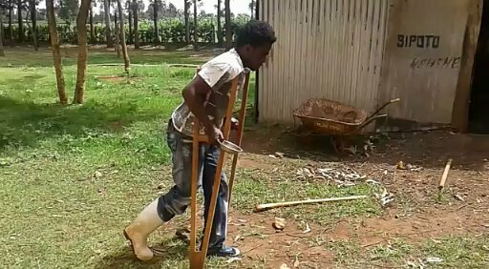
All stakeholders including Government to ensure that all Social Services are provided to Children with Disability to reduce poverty.

ZIMBABWE PARENTS OF HANDICAPPED CHILDREN ASSOCIATION

MAKING THE VOICES OF CHILDREN WITH DISABILITIES HEARD PROJECT 2017-2020

THE MONITORING AND EVALUATION REPORT 2020
(Headway Africa Funded Project)

Compiled by; Rev. Charles Chiviru
15 B – 6TH Avenue
Parktown. Waterfalls
Zimbabwe.
Mob: 263-772 415 812
263-0719 41581
Email: zecdtawu@gmail.com

